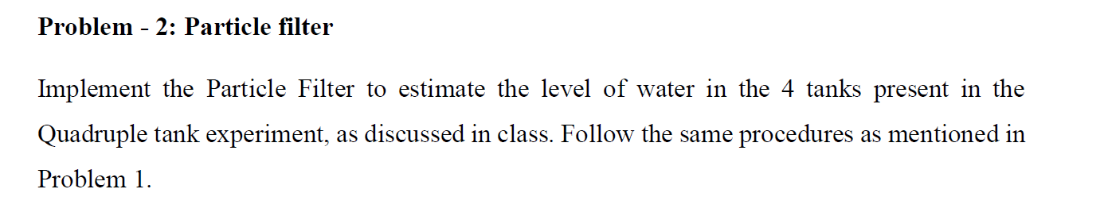

**Particle Filter:**

This report will describe and show the result of particle filter implementation, following the methodology outlined in the paper "The Quadruple-Tank Process: A Multivariable Laboratory Process with an Adjustable Zero" by Karl Henrik Johansson.

**Introduction:**

Particle filter, also known as Sequential Monte Carlo (SMC) methods, is a powerful and widely used technique in the field of state estimation and filtering. Its application has been particularly significant in the control of complex multivariable systems. In this context, **Karl Henrik Johansson's** seminal work titled "**The Quadruple-Tank Process: A Multivariable Laboratory Process with an Adjustable Zero**" has served as a pivotal reference for researchers exploring particle filter implementation. This sophisticated laboratory process offers an ideal platform for investigating the effectiveness and efficiency of particle filters in addressing real-world challenges.

Johansson's research delves into the complexities of multivariable systems and, specifically, the quadruple-tank process, a laboratory setup with an adjustable zero. The process involves four interconnected tanks, and its inherent nonlinearity and interactions among variables present formidable hurdles in state estimation and control. The utilization of particle filters in this context showcases their ability to handle nonlinear and non-Gaussian systems, making them a favourable choice for state estimation.

The practical implementation of particle filters in the quadruple-tank process demonstrates the elegance of these algorithms in addressing the issues of uncertainty and noise inherent in real-world systems. By employing a vast number of particles to represent the system state, particle filters offer a powerful tool to estimate the underlying states with high accuracy. This ability is particularly valuable in situations where traditional linear filters may falter due to the limitations of the underlying model.

Furthermore, the adjustable zero in the quadruple-tank process introduces an additional dimension of complexity, as it necessitates adaptive filtering techniques. Particle filters, with their inherent ability to handle changing model parameters and adapt to varying system dynamics, prove to be a natural fit for this type of problem. As researchers delve deeper into the intricacies of particle filter implementation using Johansson's work as a foundation, new insights and advancements emerge, further solidifying particle filters as a vital tool in the state estimation and control of multivariable systems.

**Reference Literature Overview:**

Karl Henrik Johansson's work on the Kalman Filter implementation for the Quadruple-Tank Process provides valuable insights into the application of the Kalman Filter in a multivariable laboratory process with an adjustable zero. This work, published in <http://www.diva-portal.org/smash/get/diva2:495784/FULLTEXT01.pdf>  
, has been influential in the field of control systems and has contributed to the understanding of the Kalman Filter's effectiveness in state estimation and control.

The Quadruple-Tank Process is a well-known benchmark system that exhibits complex dynamics, including interdependencies between tanks and the presence of an adjustable zero. His study focuses on the application of the Kalman Filter to estimate the tank levels accurately in the presence of measurement noise and system uncertainties.

His work emphasizes the importance of considering the unique characteristics of the Quadruple-Tank Process when designing the Kalman Filter. By analysing the process dynamics and noise sources, Johansson derives a suitable state-space model for the system. The derived model incorporates the interdependencies between the tanks and the adjustable zero, enabling accurate state estimation.

One significant contribution of his work is the incorporation of process noise covariance and measurement noise covariance matrices into the Kalman Filter formulation. By properly characterizing these covariance matrices, Johansson demonstrates improved convergence and estimation accuracy for the Quadruple-Tank Process.

Moreover, Johansson investigates the impact of different noise sources and their effects on the estimation process. He highlights the significance of properly modelling and accounting for measurement noise, process noise, and system uncertainties. Through experimental validation, Johansson demonstrates the effectiveness of the Kalman Filter in handling these noise sources and accurately estimating the tank levels.

His work also discusses the implications of system identification and model uncertainty on the Kalman Filter performance. He emphasizes the need for adaptive and robust filtering approaches to handle uncertainties in the system model. By incorporating adaptive techniques, Johansson showcases the ability to adapt the Kalman Filter to variations in the system parameters and achieve accurate state estimation.

We are trying to implement the Particle filter using the same set up proposed by **Karl Henrik Johansson** and compare the result of the same with Kalman filter output.

**Experimental Result:**

I have used two approaches to implement the particle filter.

* In first approach it provides a simplified version of the particle filter implementation, focusing on the core steps of prediction, update, and resampling without explicitly defining separate functions for each step. Here I have not considered the system dynamics in detail but utilize random noise (Gaussian noise with mean 0 and standard deviation 0.1) to model process noise in the system during the prediction step.
* In second approach it provides a comprehensive and detailed function-based structure for the particle filter. It clearly defines functions for the prediction, update, and resampling steps of the particle filter with all the relevant system dynamic parameter must be taken care of.

**Visualization of Particle Filter Result:**

* **Result of Particle Filter using First approach:**

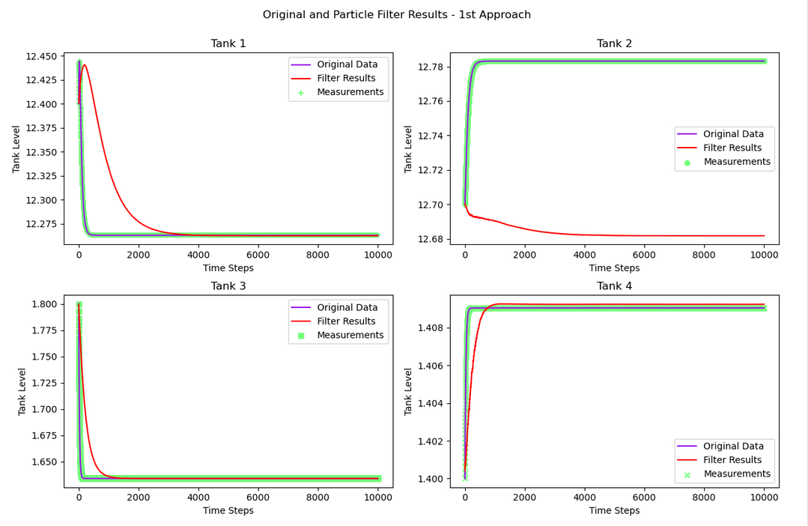

Figure : Particle Filter Result - Approach 1



Figure : Particle Filter Result - Approach 1

* **Result of Particle Filter using Second approach:**

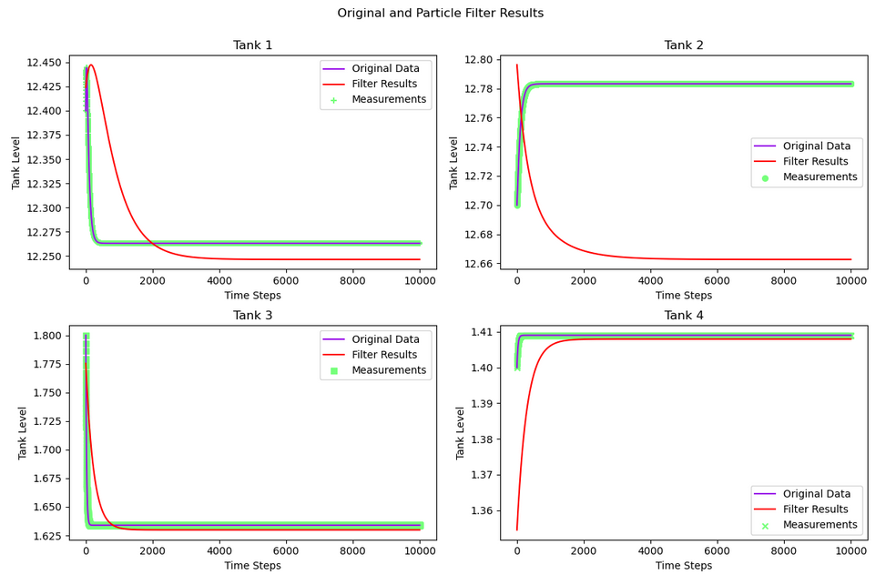

Figure : Particle Filter Result - Approach 2



Figure : Particle Filter Result - Approach 2

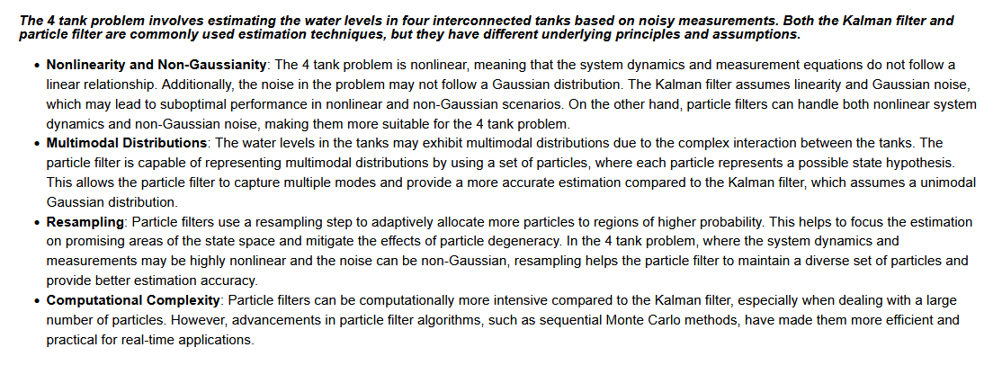

**Kalman Filter Vs Particle Filter:**

**Comparison between Kalman Filter 1st Approach with Particle Filter 1st Approach :**

**Comparison between Kalman Filter 1st Approach with Particle Filter 2nd Approach :**

**Comparison between Kalman Filter 2nd Approach with Particle Filter 1st Approach :**

**Comparison between Kalman Filter 2nd Approach with Particle Filter 2nd Approach :**

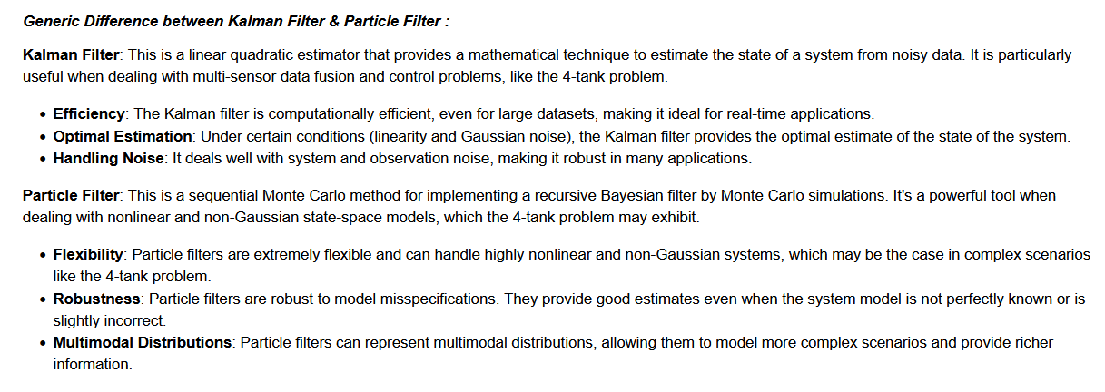

**End of Report**